Hi All .... sharing

Note:  Monitoring % used in very large tablespaces can trigger alerts when there is plenty of freespace available .... even if you have thresholds at 97 or higher %.

Monitoring by remaining freespace if more accurate ... specially if you know your db growth.   (You can get db growth using OEM Information Publisher Report under Enterprise/Reports)

è Follow this process to avoid generating alerts while changing from % to MB.

1.  In OEM: Go Oracle Database / Monitoring / Metrics and Collection Settings and look for Tablespace Full metric.

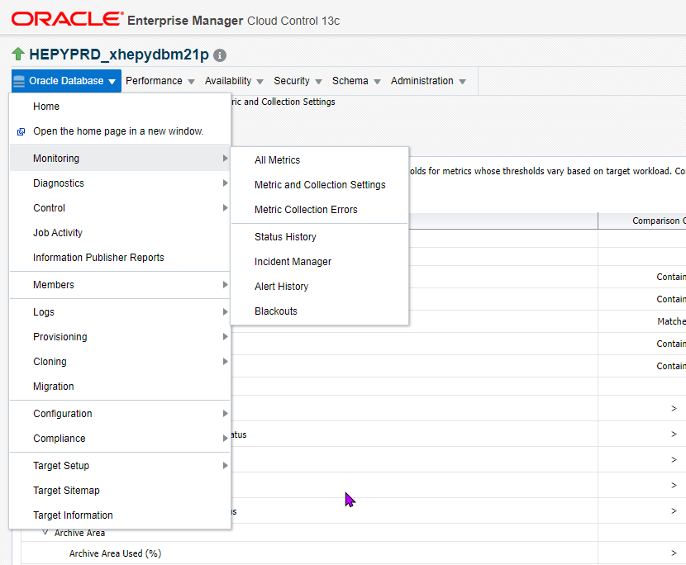

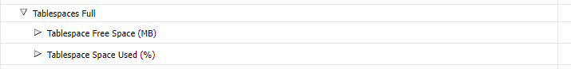

IF you only see Tablespace Free(%) like below go to Step 2

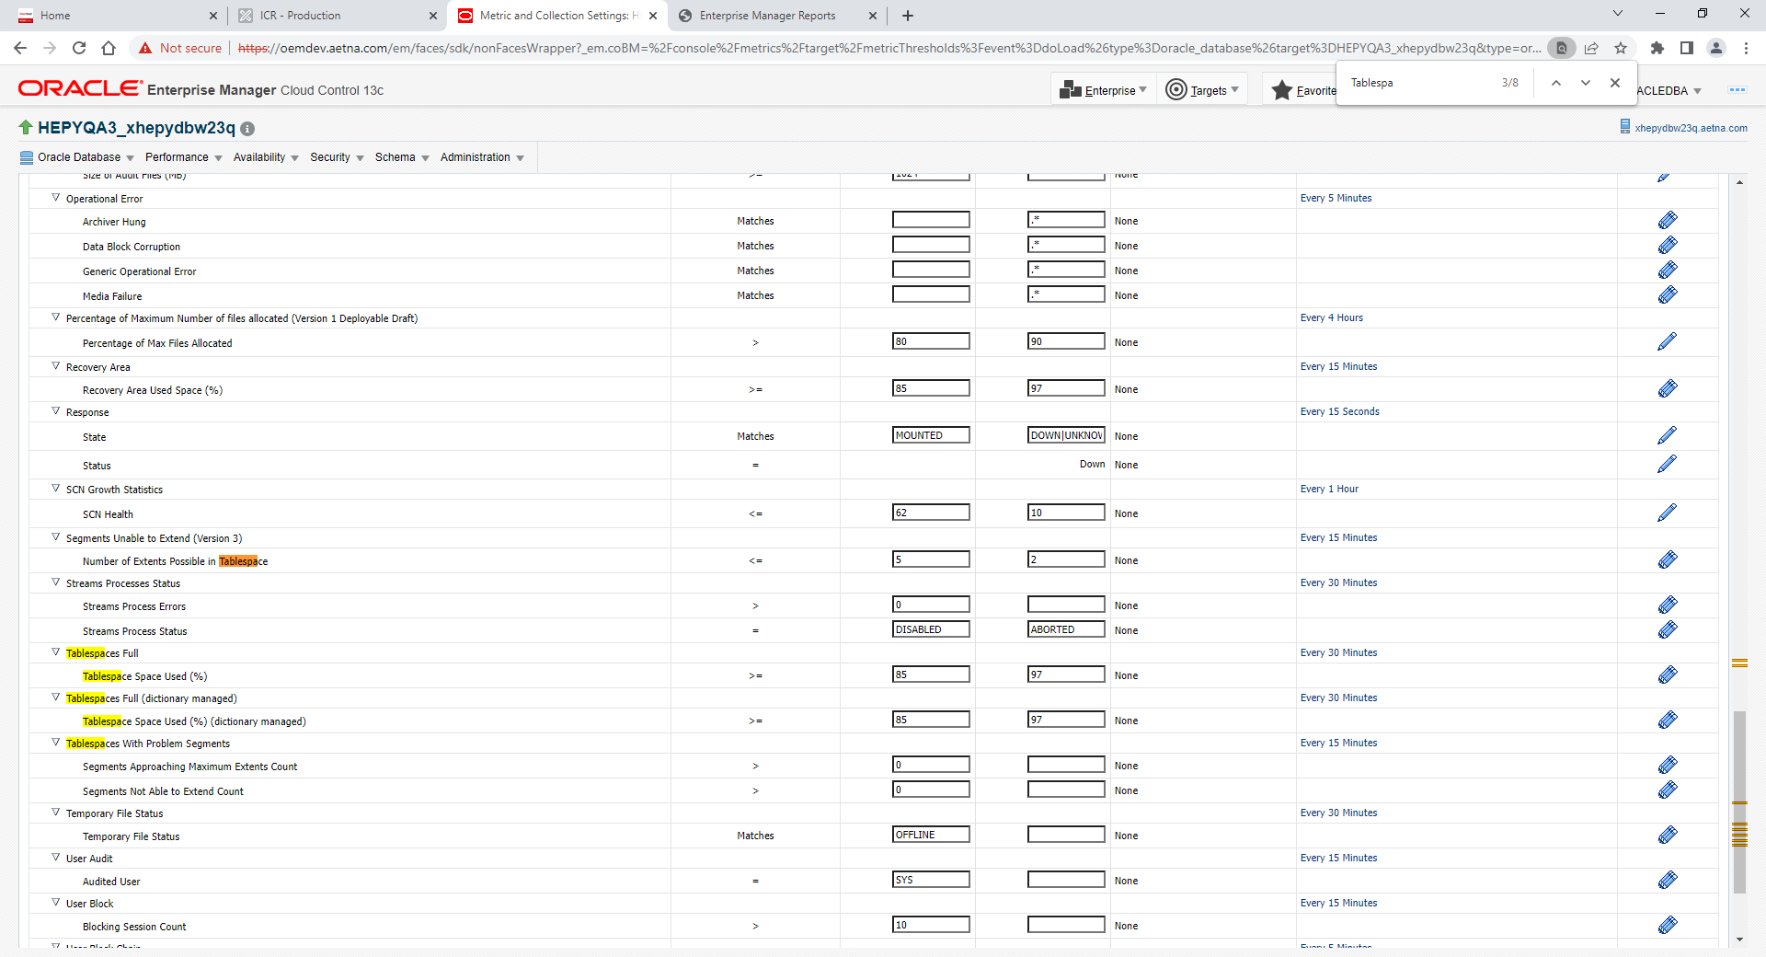

Step 1

a) Under tablespace %  ... add the tablespace to monitor by MB using blank threshold values so they are ignored by the % metric **and save**.  Note: “All others” cannot be removed.

b) Under tablespace MB ... add the tablespace to monitor by MB with critical and warning values and save.

CXT Example:

These values will give us a 2 / 1 month alert for Warning / Critical respectively based on the db growth.

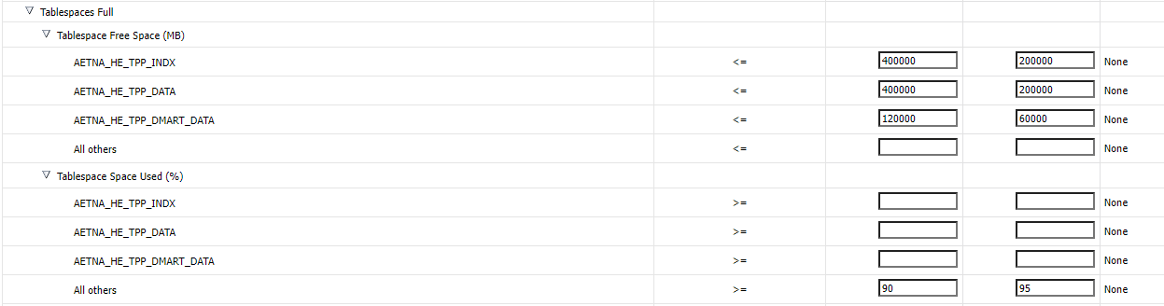

Step 2 – Select All metrics under View as example below

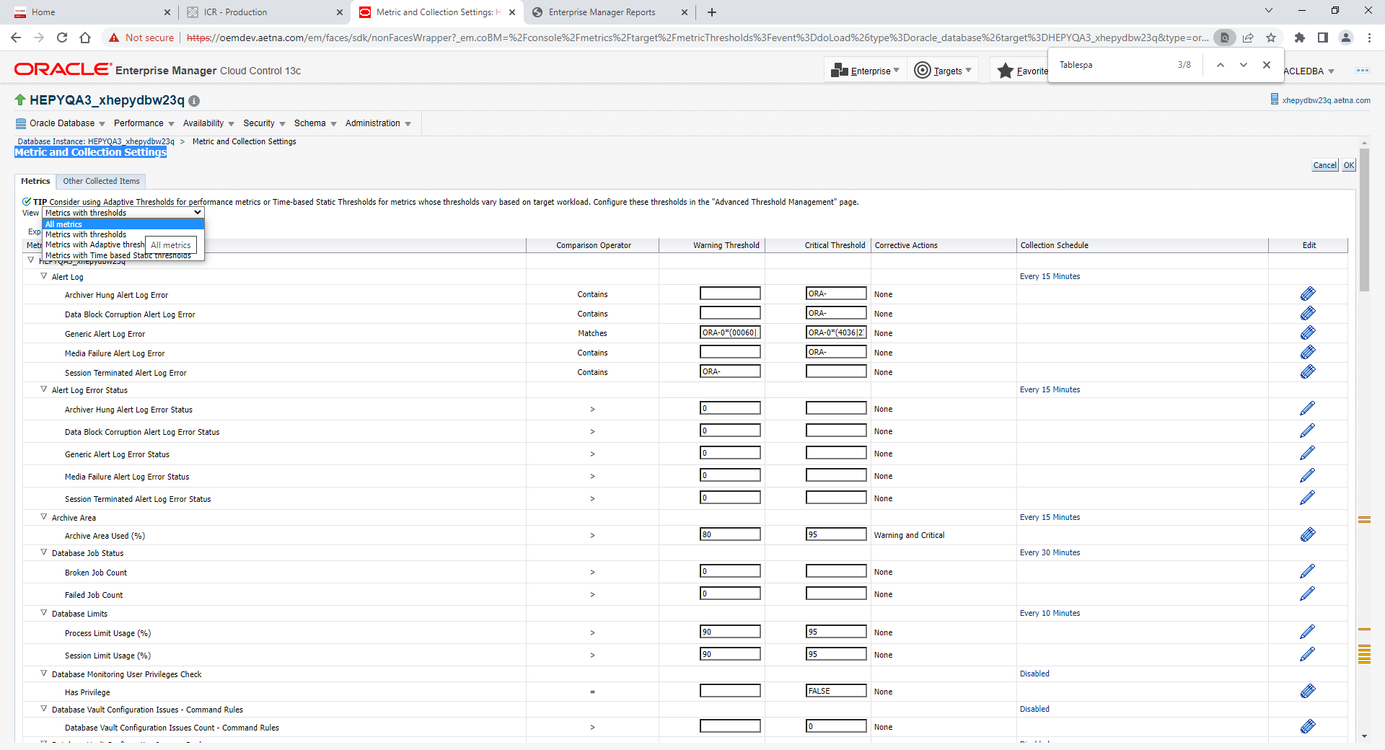

Scroll down and find area Tablespaces Full🡪 Tablespace Free Space (MB)

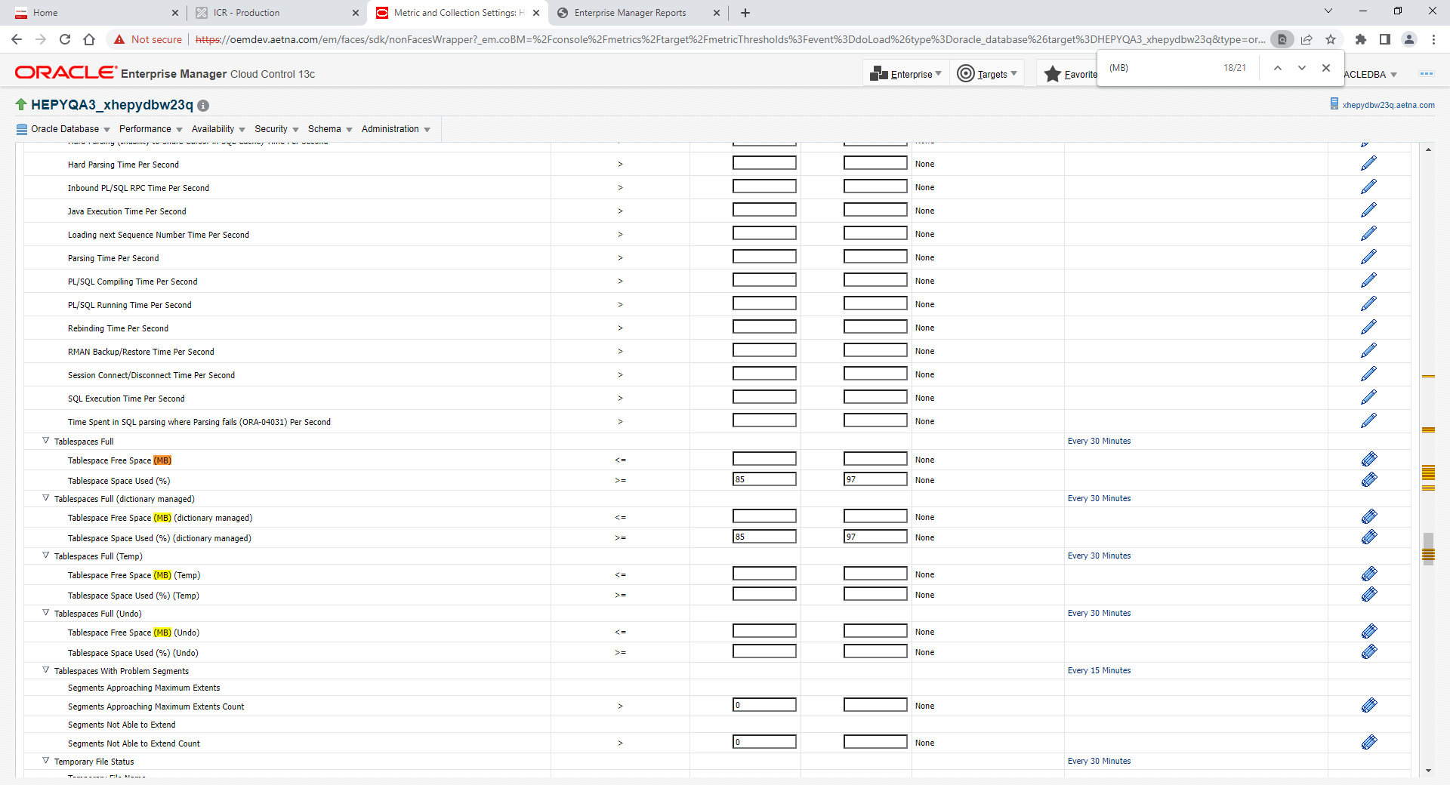

Click blue edit ribbon on left and add at least one tablespace threshold as example below

Click add button first on that screen

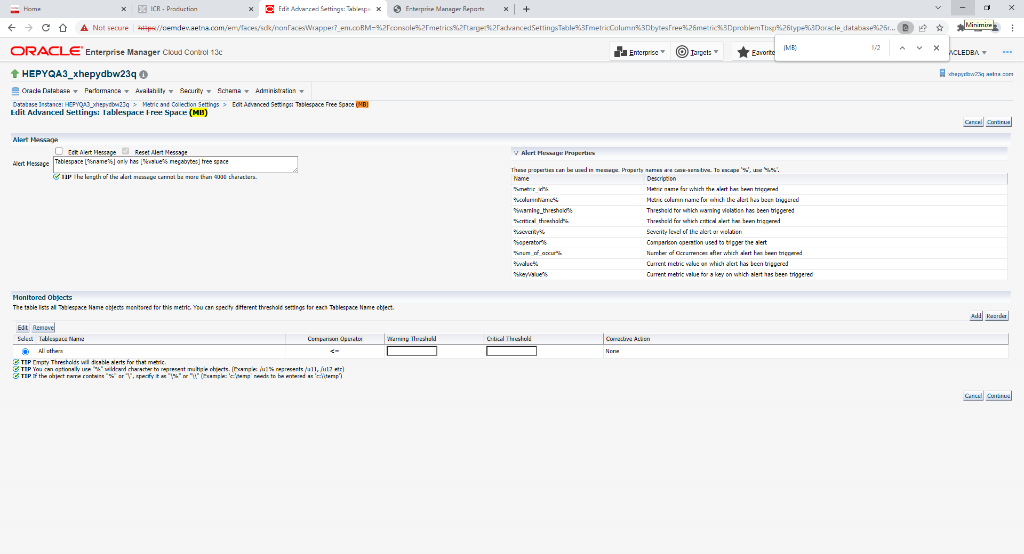

Add one tablespace for example and hit continue button

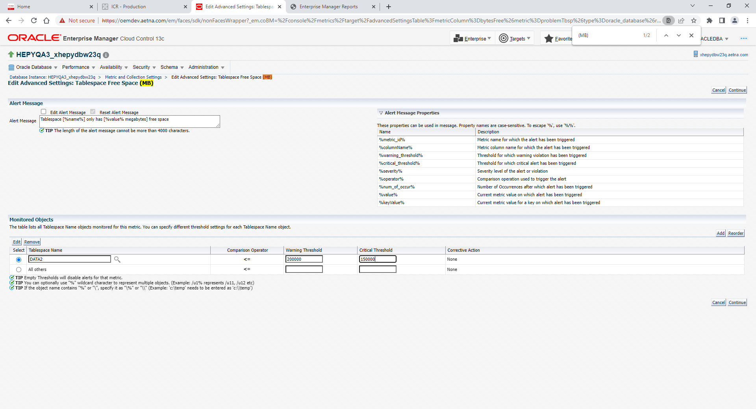

Clock OK on the top left

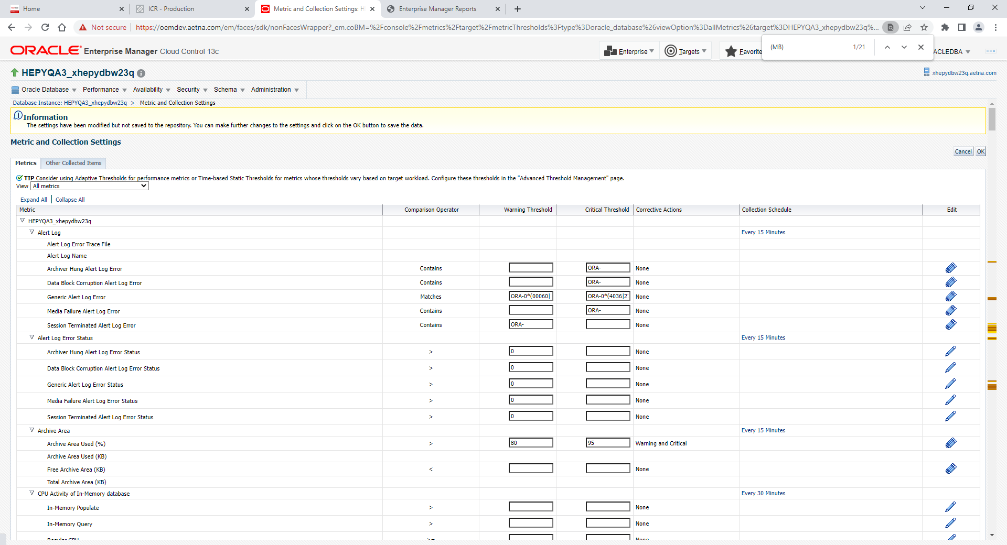

After go back to Metrics with threshold view and Tablespace Free Space (MB) should be there. So you can continue to add more tablespaces to monitor by MB per Step 1

